# Day:4 Creating Landscape

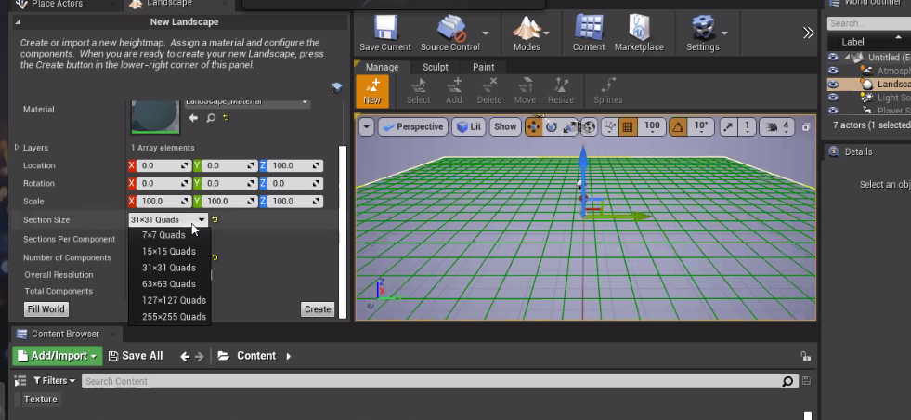create → to create landscape

play → to play the game in your landscape

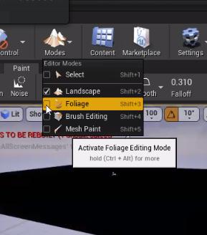

click on modes>landscape to create landscape

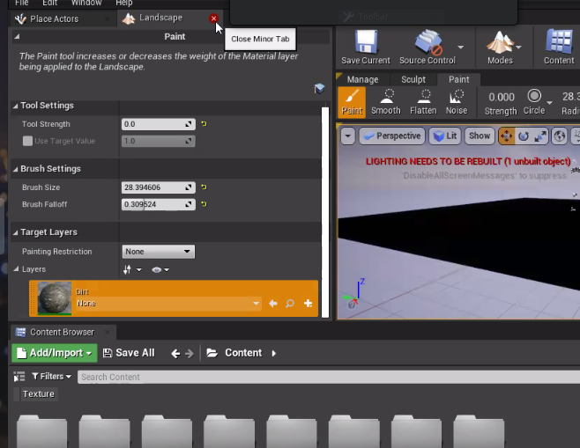click on paint and then select a material from layers

## Marketplace:

Market place has pre-made models

Goto marketplace > select a model> add it to your project

## Create exe for Mobile:

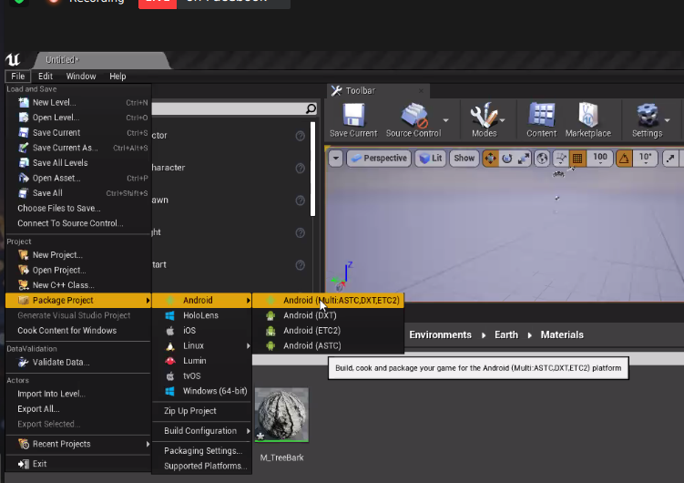Use blend to blend multiple texture

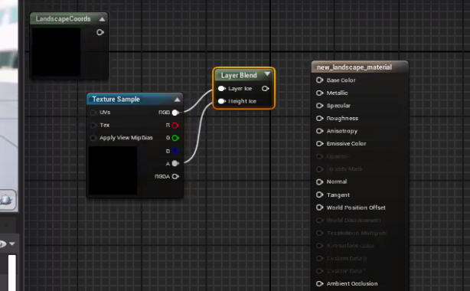

landscape coords → how many bricks are separated in a single texture

normal → create fake depthness (un-eveness)

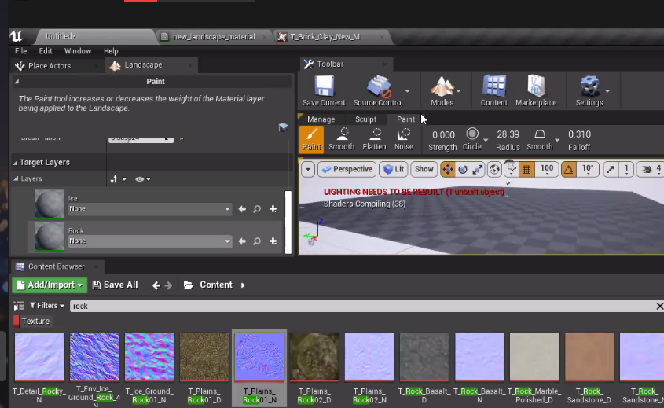

goto landscape> paint> under target layers we can we your created materials

and then paint it

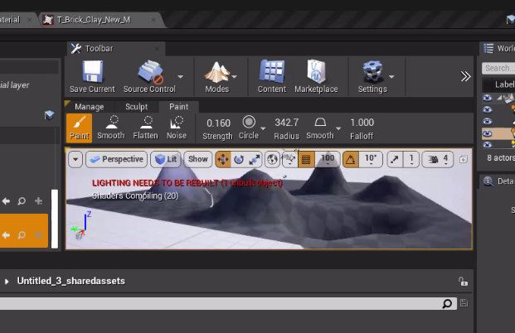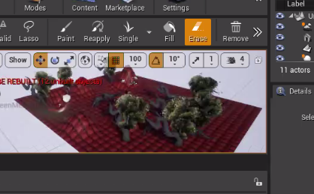use single to plant a tree and eraser to remove it